Computer Systems – Lab 02
Name: Ruffin Remad
Student ID: 103840173

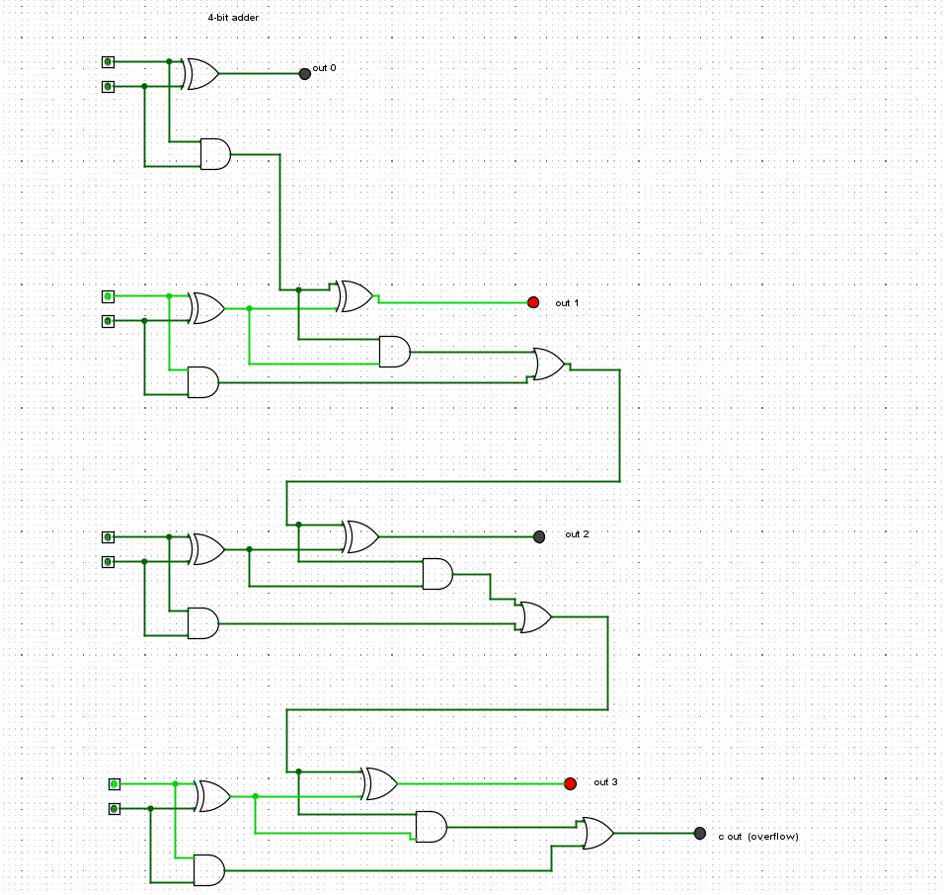

Figure 1- 4-bit adder

Input A | Input B | Output
0101 | 0000 | 0101
0101 | 0001 | 0100
0101 | 0010 | 0111
0101 | 0011 | 0110
0101 | 0100 | 0011
0101 | 0101 | 0010
0101 | 0110 | 0000
0101 | 0111 | 0001
0101 | 1000 | 1101
0101 | 1001 | 1100
0101 | 1010 | 1111
0101 | 1011 | 1110
0101 | 1100 | 1011
0101 | 1101 | 1010
0101 | 1110 | 1000
0101 | 1111 | 1001

Table 1

Figure 2- RS flipflop
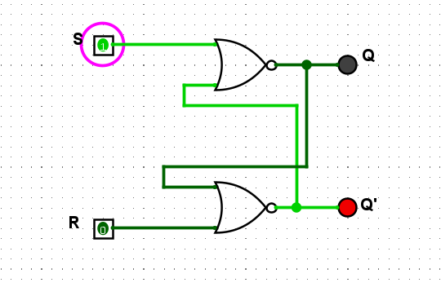
Table 2
Set | Reset | Q | Q’
1 | 0 | indeterminant | indeterminant
1 | 1 | 0 | 0
0 | 1 | 1 | 0
1 | 1 | No change | No change

Ans.11: The circuit remembers when one of the inputs is set to 1. The output will not change unless the set button turned off first. This is useful as the circuit stores the inputs until any manual interaction.
Ans.12: Both the LED lights turn off which means the circuit enters an unstable state since there is no mechanism to control the timing of single reception.

Figure 3- D flipflop
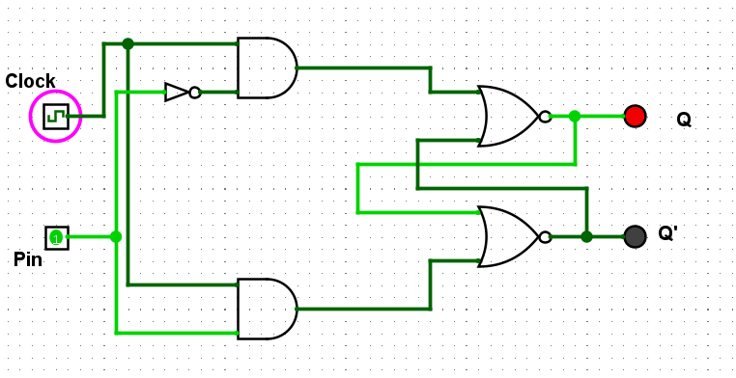

Clock | Pin | Q | Q’
0 | 0 | 1 | 0
0 | 1 | 1 | 0
1 | 1 | 1 | 0
1 | 0 | 0 | 1

Table 3

Ans.15: The D flipflop is similar to an RS flipflop but has one input pin and a clock instead of two pins. This is to overcome the illegal state when two inputs are turned on. The circuit changes its state only during a clock pulse. Thus, the issue of illegal state is solved allowing to store the required value.
Ans.16: A clock is an electrical device in a circuit that coordinates the actions of the circuit by regulating the data flow. This assures the predictability of the output.
Ans.17: The output only changes when the clock pulse is switched on and the input of the pin is set high or low.

Figure 4- JK flipflop
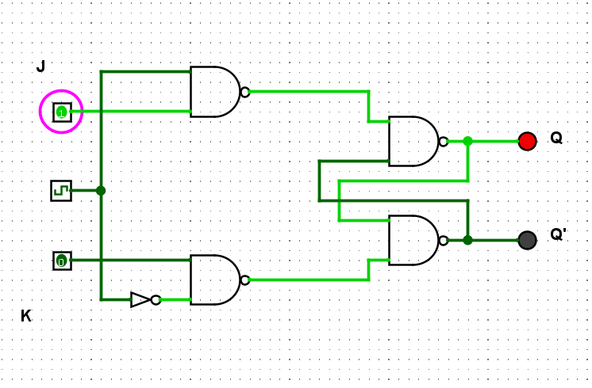

Table 4
J | K | Q (when clocked) | Q’(when clocked)
0 | 0 | No change | No change
1 | 0 | 1 | 0
0 | 1 | 0 | 1
1 | 1 | Toggle | Toggle

Ans.20: A JK flipflop is an RS flipflop with an additional input from a clock. During a clocked pulse, if the inputs of J and K (1 and 0 to 0 and 1) are interchanged, the circuit changes from state reset to set position like it does in D flipflop.
Ans.21: When both J and K switched to 1, both outputs start changing to on and off which leads to toggling. This happens in a T flipflop.

